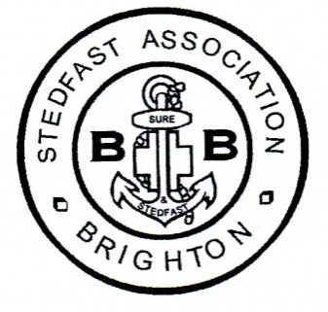
Membership Form for 2017
May we remind you that subscriptions are due, the present recommended subscription for members and associate members is £10-00 per year (more/less if you wish).
Subscription/Contribution enclosed £..........

Cheques payable to “ Stedfast Association “.. please
or By Annual Standing Order (Attached)
Company...........................................................
Name..................................................................
Address...............................................................
....................................................................
.................................................................... Tel Number...................................
Post Code......................................

E mail |  |  | Post
Confirm e-mail .........................................................................
Newsletter via email OR Hard copy by post...........Please indicate in one box
Old Boy........... Officer.... ....... Helper ........... Friend /Supporter........... Band Member...........
Please return this completed form together with your subscription to:-
The Secretary Alan Caperon
72 Poulter’s Lane
Worthing
West Sussex BN14 7SZ

If you wish to send any letter with a BB story for us to include in the newsletter, please tick
Newsletter
this box:-

Should you no longer wish to remain on our mailing list, would you also please inform the Secretary, telephone 01903 692481 or email to alan.caperon@hotmail.co.uk

